Temos que criar um evento para trabalhar com o Push

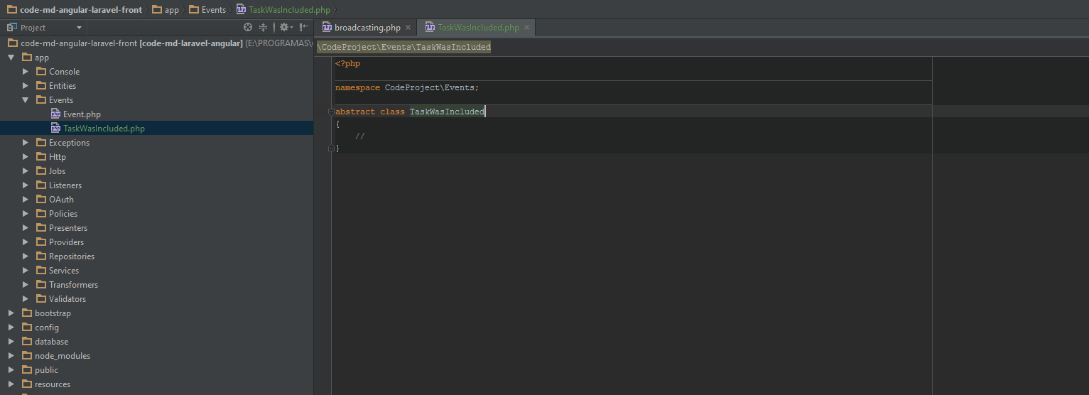

**<?php  
  
namespace** CodeProject\Events;  
  
**use** CodeProject\Entities\ProjectTask;  
**use** Illuminate\Contracts\Broadcasting\ShouldBroadcast;  
**use** Illuminate\Queue\SerializesModels;  
  
  
**class** TaskWasIncluded **extends** Event **implements** ShouldBroadcast  
{  
 //serializar os models - em json  
 **use** SerializesModels;  
 **public** $task;  
  
 **public function** __construct(ProjectTask $task)  
 {  
 $this->task = $task;  
 }  
  
 **public function** broadcastOn()  
 {  
 //canal que nos criamos com o nosso servico de real time  
 **return**['user.'.\Authorizer::*getResourceOwnerId*()];  
 }  
}